**Worksheet – 2.2**

**Student Name:** Vivek Kumar  **UID:** 21BCS8129

**Branch:** BE-CSE (LEET) **Section/Group:** 809/A

**Semester:** 4th **Date of Performance:** 30/03/2022

**Subject Name:** Programming in Python Lab  **Subject Code:** 20CSP-259

**1. Aim/Overview of the practical:**

1. Write a Python program to get a list, sorted in increasing order.
2. Write a Python program to print a specified list after removing the 0th, 4th and 5th elements, Sample List: ['Red', 'Green', 'White', 'Black', 'Pink', 'Yellow'], Expected Output: ['Green', 'White', 'Black'].

**2. Task to be done/ Which logistics used:**

1. Write a Python program to get a list, sorted in increasing order.
2. Write a Python program to print a specified list after removing the 0th, 4th and 5th elements, Sample List: ['Red', 'Green', 'White', 'Black', 'Pink', 'Yellow'], Expected Output: ['Green', 'White', 'Black'].

**3. Steps for experiment/practical/Code:**

1. Write a Python program to get a list, sorted in increasing order.

**Sourse Code:**

def last(n):

return n[-1]

def sort(tuples):

return sorted(tuples, key=last)

list_tup = []

item=[]

n = int(input("Enter number of elements : "))

for i in range(0, n):

print("Enter {}th of Tuples 2 elements: ".format(i+1))

for j in range(0,2):

ele = int(input())

item.append(ele)

list_tup.append(tuple(item))

item=[]

print("Sorted:")

print(sort(list_tup))

1. Write a Python program to print a specified list after removing the 0th, 4th and 5th elements, Sample List: ['Red', 'Green', 'White', 'Black', 'Pink', 'Yellow'], Expected Output: ['Green', 'White', 'Black'].

**Sourse Code:**

*#As per the given Exasmple*

color = ['Red', 'Green', 'White', 'Black', 'Pink', 'Yellow']

print('Sample List: ',color)

new_color=[]

for i in range(len(color)):

if i not in (0,4,5):

new_color.append(color[i])

print('Expected Output: ',new_color)

*#Program with Dynamic value*

list_items=[]

new_list=[]

n = int(input("Enter number of elements you want in List: "))

for i in range(0, n):

ele = input("Enter {}th of elements: ".format(i))

list_items.append(ele)

rn=int(input("Enter How many items you want to remove from List: "))

item=[]

if n>=rn:

for j in range(rn):

ele = int(input('Enter The Item Index Value: '))

item.append(ele)

item=tuple(item)

print('Given List: ',list_items)

for i in range(len(list_items)):

if i not in item:

new_list.append(list_items[i])

print('Expected Output: ',new_list)

else:

print('Invalid Input')

**4. Result/Output/Writing Summary:**

**II**. **Write a Python program to print a specified list after removing the 0th, 4th and 5th elements, Sample List: ['Red', 'Green', 'White', 'Black', 'Pink', 'Yellow'], Expected Output: ['Green', 'White', 'Black'].**

**Output:**

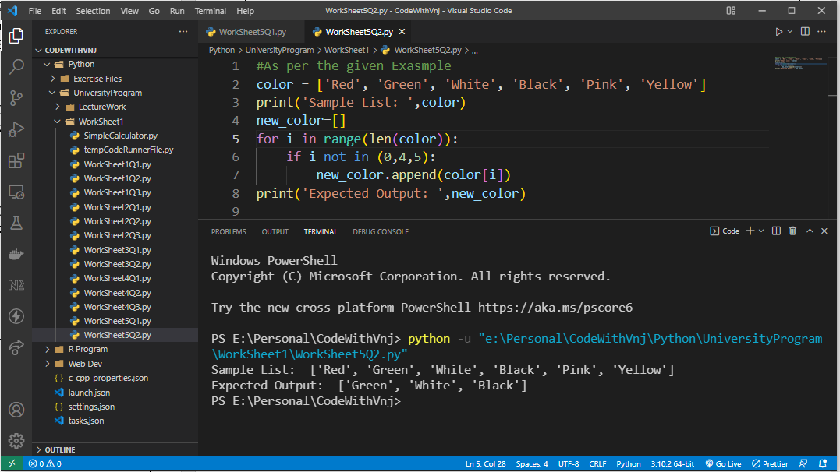

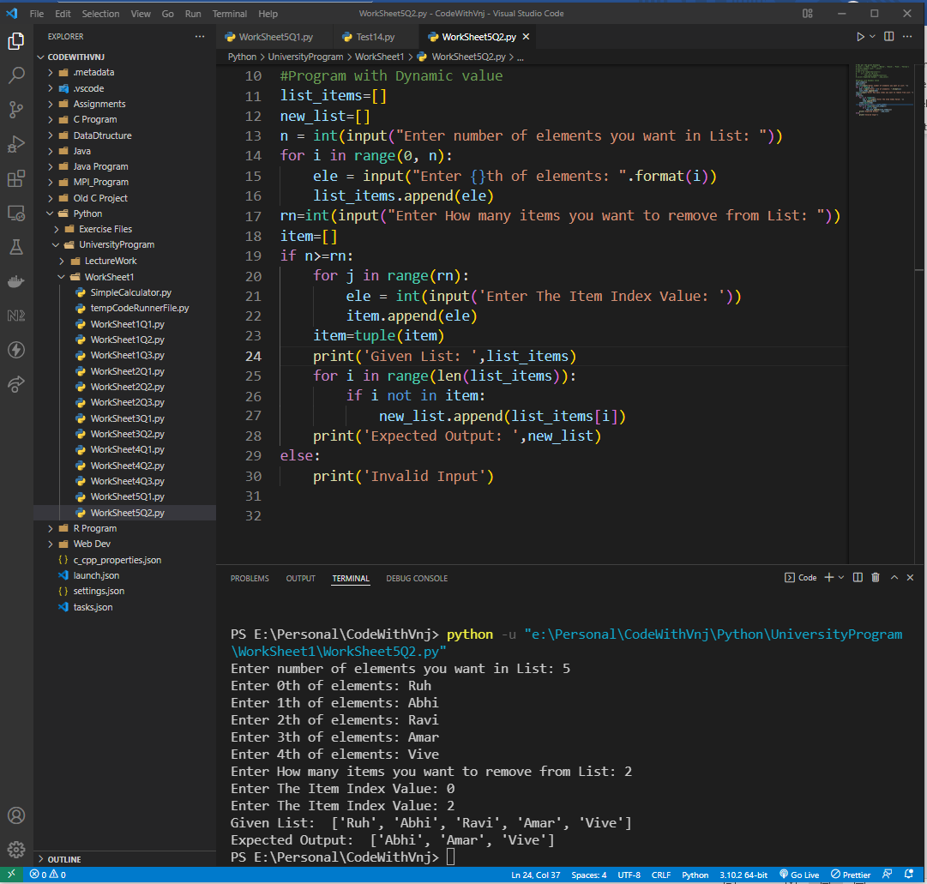

1. **Write a Python program to get a list, sorted in increasing order.**

**Output:**

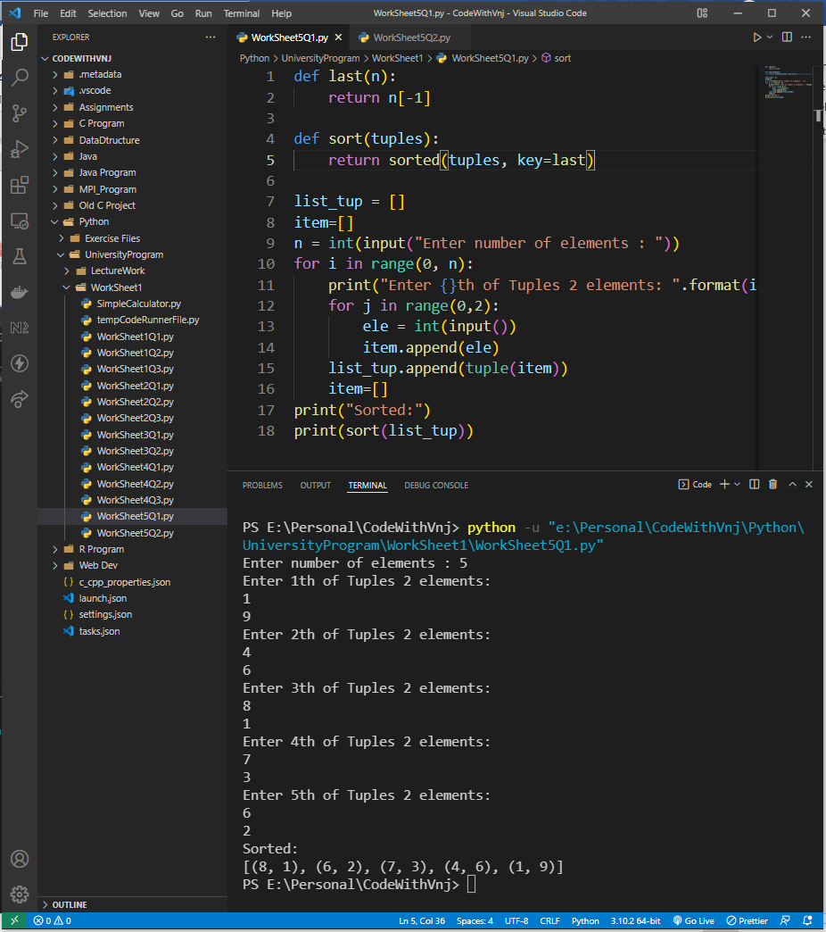

**Note:** There is a small Confusion in output part. Because of size of the Screenshot image, I have Arranged 2nd Program output first and 1st Program output in last.

**Learning outcomes (What I have learnt):**

**1.** I have learnt, how to take List as well as Tuple Input from User.

**2.** Learnt to find the sorted tuple with their last element.

**3.** Learnt to List Manipulation.

**Evaluation Grid (To be created as per the SOP and Assessment guidelines by the faculty):**

|  |  |  |  |
| --- | --- | --- | --- |
| Sr. No. | Parameters | Marks Obtained | Maximum Marks |
| 1. |  |  |  |
| 2. |  |  |  |
| 3. |  |  |  |
| 4 |  |  |  |